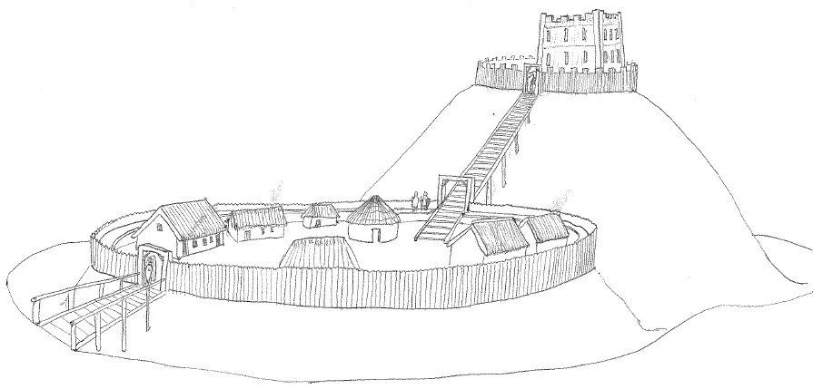
Granard Motte Community Enterprise CLG

Seek a suitably qualified Manager for their Granard Motte Knights and Conquest Visitor Centre.
Applicants for this role must have:
Experience in marketing and business.
Experience in tourism and event management.
Excellent Computer skills.
Full and clean driving licence.
Suitable candidates must be good communicators and be willing to work as part of a team and on their own initiative. Experience in developing a project from start to finish would be an advantage.
For Application form, details of the job description and remuneration package please check our website www.granardmotte.ie
Completed Applications should be sent to: The Chairman, Knights and Conquest, GMCE CLG, Dublin St., Granard, Co. Longford, Ireland, N39 DE06 before 12 noon on Tuesday 31st December 2019.
This project is supported by the Department of Rural and Community Development and Pobal through the Community Services Programme.

