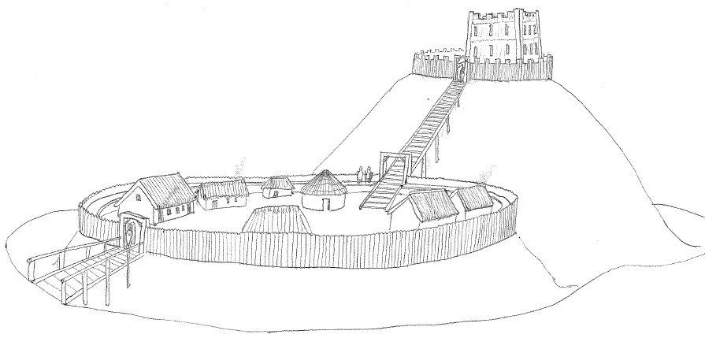

Granard Motte Community Enterprise CLG
GMCE CLG, Dublin St., Rathcronan, Granard, Co. Longford, Ireland. N39 DE06
Job Description

The Manager is responsible for promoting the Interpretive Centre Knights and Conquests and devising tourist development initiatives/campaigns with the aim of generating and increasing revenue. The role of the Manager is a combination of marketing, public relations and management. It also involves lots of planning and preparation.
Typical responsibilities of the job include:
· Supervising staff (and/or volunteers)
· Preparing tourist or visitor information
· Producing promotional material and displays
· Managing budgets
· Writing reports, business plans and press releases
· Making presentations
· Maintaining statistical and financial records
· Undertaking day-to-day centre management and administration
· Liaising with local businesses and the media
· Market research.
· obtaining funding and grants for the operation & maintenance and for the running of the complex.
· Liaise and help organise festivals and events.
. Ensure compliance with Health & Safety and all other relevant legislation.
. Handle customer complaints and queries.
. Day-to-day management of the entire Centre as it develops.

Qualifications and training required
Graduates with degrees in languages, travel, tourism, leisure, business studies, marketing, management or journalism are normally at an advantage. Relevant work experience is essential, and can be gained via seasonal or vacation employment, or by working as a volunteer or paid assistant in a tourist information centre. Experience gained in museums or information work or any commercial area (sales, marketing, retailing) can also be helpful.

Further Information:

- 39 hr working week on any day.
- A competitive remuneration of 32,000 euro per annum will be offered to the successful candidate.
- There will be a six-month probation period.
- No electronic applications will be accepted.
- The closing date for applications is 12 noon on Tuesday 31st December 2019

Granard Motte CLG is an equal opportunity employer

This project is supported by the Department of Rural and Community Development and Pobal through the Community Services Programme.

