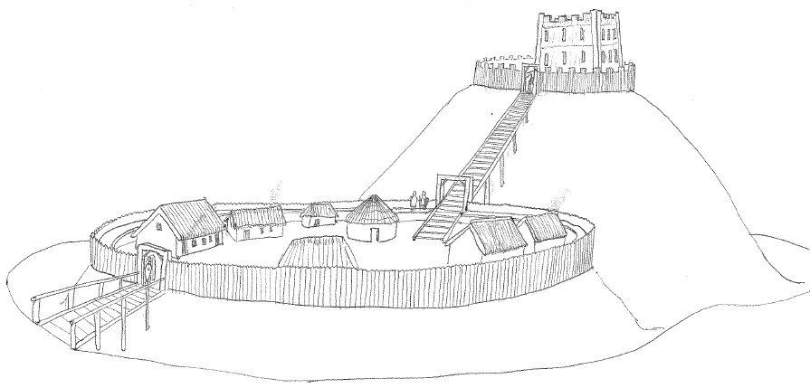

**Granard Motte Community Enterprise CLG**

GMCE CLG, Dublin St., Rathcronan, Granard, Co. Longford, Ireland. N39 DE06

**APPLICATION FORM**

|  |
| --- |
| ***MANAGER FOR***  ***KNIGHTS & CONQUESTS CENTRE & PARK*** |

**Please submit application form by 12 noon Tuesday 31st December 2019 by email to** [**info@granardmotte.ie**](mailto:info@granardmotte.ie)

**or by post to**

**The Chairman, Knights and Conquest, GMCE CLG, Dublin St., Granard, Co. Longford, Ireland, N39 DE06**

# Responsibility for ensuring timely and correct delivery of applications rests with the applicant.

Allegations that any application form or letter relating to it has been lost or delayed in the post will not be considered by Granard Motte Community Enterprise unless a Post Office Certificate of Posting is produced in support of such allegations.

Completed applications should not be returned by fax or email.

**All application forms received will be acknowledged.**





**Title: Mr. Ms. Please Tick (√) as appropriate**

**Name in Full:**_________________________________________________________________________

(BLOCK LETTERS)

**Address for Correspondence:**___________________________________________________________

(BLOCK LETTERS)

_____________________________________________________________________________________

_____________________________________________________________________________________

**Email Address: __________________________**

#### Contact Telephone Numbers -Home: ____________________ Mobile: _____________________

*Granard Motte Community Enterprise may need to contact you during the recruitment process, it is important that the contact details you have given above are accessible by you at all times.*

**Do you possess a full-unendorsed Driving Licence:** **Yes** □ **No** □

**If Yes, Please give details of class of licence:** ____________________________________

#### GENERAL EDUCATION

|  |  |  |  |
| --- | --- | --- | --- |
| **School or College** Attended | **Period** | **Examination Taken (with dates)** | **Result**  **(Pass or Honours)** |
|  |  |  |  |
|  |  |  |  |
|  |  |  |  |
|  |  |  |  |
|  |  |  |  |

#### ACADEMIC, PROFESSIONAL OR TECHNICAL QUALIFICATIONS (if any):

* ***Please attach copy of qualifications to all copies of Application Form***

|  |  |  |  |  |
| --- | --- | --- | --- | --- |
| **Full Title of Qualification Awarded including Discipline e.g. B.A. B.S.c. Etc.** | **Year of Entry & Year Degree /Qualification Awarded**  **Ord. Or Hons. Level Degree**  **Full-Time or Part-Time course** | **Grade Awarded**  **Honours/ Pass**  e.g. 2nd Class Honours | **Subject(s) in Final Examination** | **Full name & address of University, College or Examining Authority** |
|  |  |  |  |  |
|  |  |  |  |  |
|  |  |  |  |  |
|  |  |  |  |  |
|  |  |  |  |  |

#### EMPLOYMENT RECORD

|  |  |  |  |
| --- | --- | --- | --- |
| **From** | **To** | **Name and Address**  **of Employer** | **Grade or Position Held. Type of Employment or Experience**  **(Short Description)** |
|  |  |  |  |
|  |  |  |  |
|  |  |  |  |
|  |  |  |  |
|  |  |  |  |
|  |  |  |  |
|  |  |  |  |
|  |  |  |  |
|  |  |  |  |
|  |  |  |  |
|  |  |  |  |

***Details of additional work experience may be attached on a separate sheet to this application form***

#### ACHIEVEMENTS / EXPERIENCE

Please indicate any particular achievement/experience, which you consider an Interview Board, should be aware of when assessing your application for the post of Manager of Granard Motte Visitor Centre & Complex.

|  |
| --- |
|  |
|  |
|  |
|  |
|  |

#### SUPPORTING ADDITIONAL INFORMATION

|  |
| --- |
|  |
|  |
|  |
|  |
|  |

**DO YOU REQUIRE A WORK PERMIT/WORKING VISA?** Yes □ No □

#### REFERENCES

Please give details of the names of two responsible persons, to whom you are well known but not related (These names should be employers from whom the GMCE CLG can request a reference. These should include your current and former employer, where possible.)

#### NAME: __________________________ NAME: _______________________________

#### POSITION: __________________________ POSITION: _______________________________

# ADDRESS: __________________________ ADDRESS: _______________________________

_____________________________________ _______________________________

_____________________________________ _______________________________

Before signing this Form please ensure that you have replied fully to all questions. You should also satisfy yourself that you are eligible under the qualifications.

*I, the undersigned, HEREBY DECLARE all the foregoing particulars to be true and give my permission for enquiries to be made to establish such matters as age, qualifications, experience and character and for the release by other people, agencies, Garda or organisations of such information as may be necessary GMCE clg for that purpose. This may include enquiries from past/present employers and the submission of this application is taken as your consent to this.*

**Signed:** _________________________________________ **Date:** ____________________

Please give details of any specific access requirements you may need to provide appropriate accommodation in respect of your attendance for a computer test and/or interview

_______________________________________________________________________________________________________________________________________________________________________________________________________________________________________________________________

Important General Information

**Granard Motte Community Enterprise reserve the right to shortlist candidates.**

**It should be clearly noted that canvassing on behalf of candidates will lead to their**

**disqualification from the competition.**

**Any employment offered is dependent on the information given being true.**

**False or misleading information or deliberate omissions may result in termination of employment.**

**Expenses incurred by candidates in attending the interview, etc., will be at the candidates own expense.**

**Granard Motte Community Enterprise CLG *is an equal opportunity employer in all employment practices.***

***This project is supported by the Department of Rural and Community Development and Pobal through the Community Services Programme.***

